**Creating MenuStrip Applications**

When creating menu strip applications, there are two issues to be considered.

1. Setup the menu structure.
2. Create event handlers for menu items.

To construct a new form we need to call the constructor. Assume we have a form in our project called

Here is an example on how to do that.

1. Create a new Windows Form Application project. Call it MemuDemo
2. Add a MenuStrip control to your application. Place it in the upper left corner of the form.

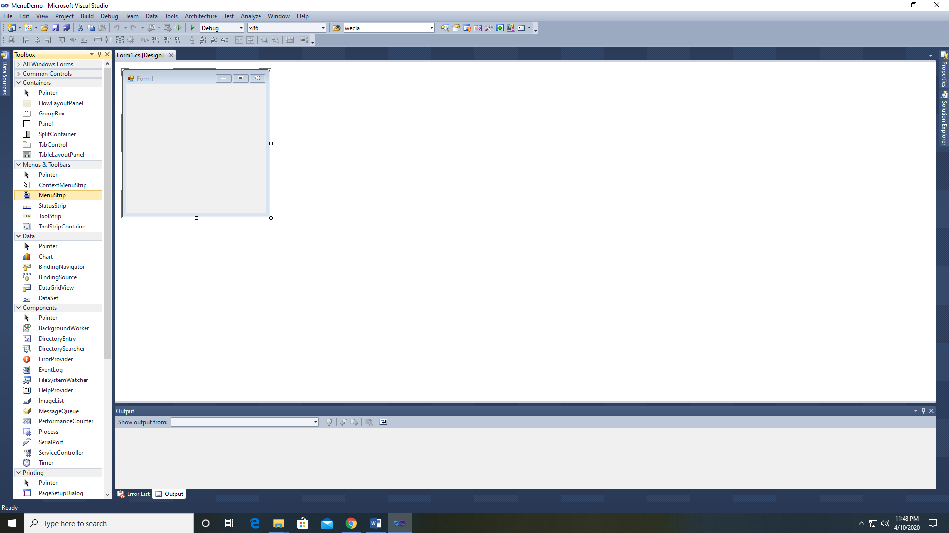 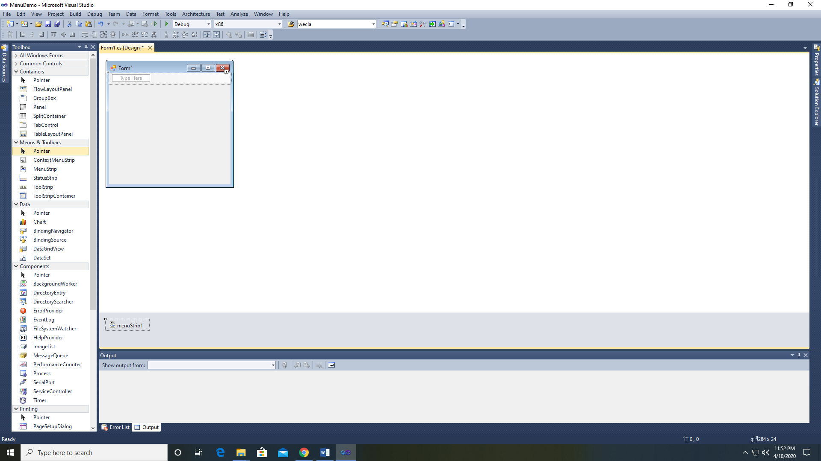

1. Add the following menu items

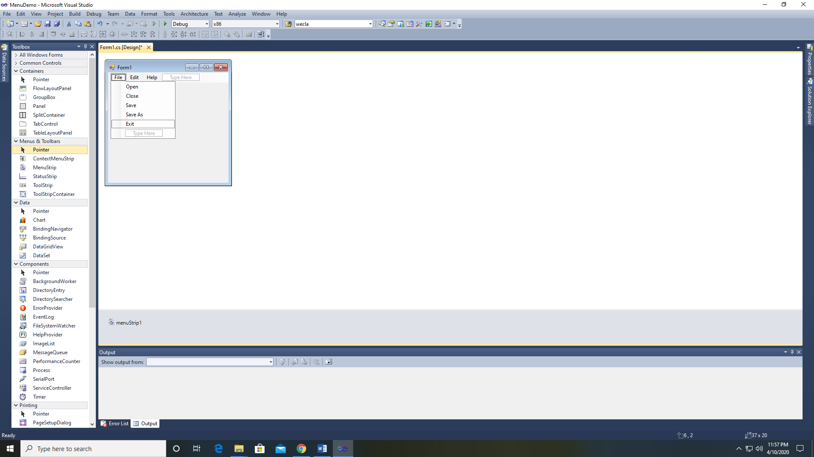 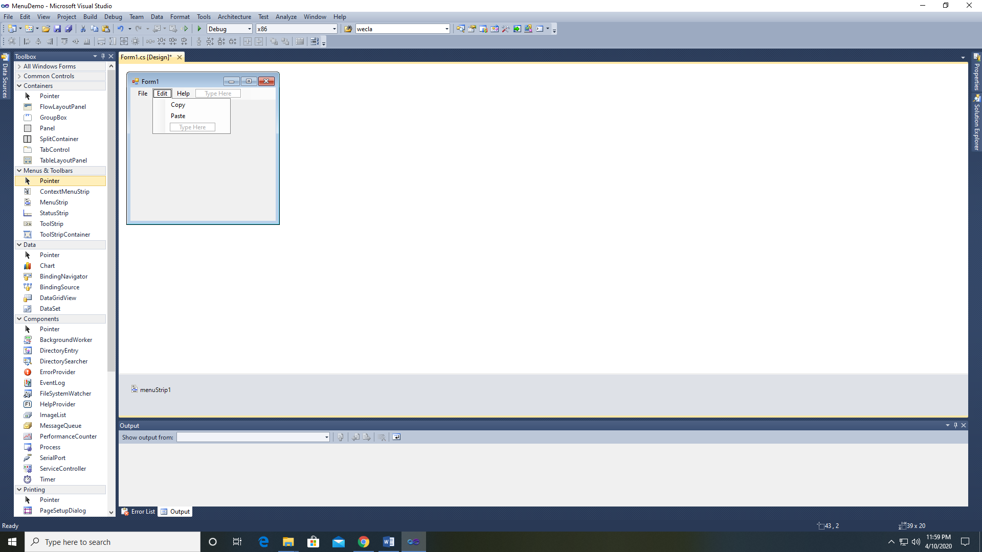 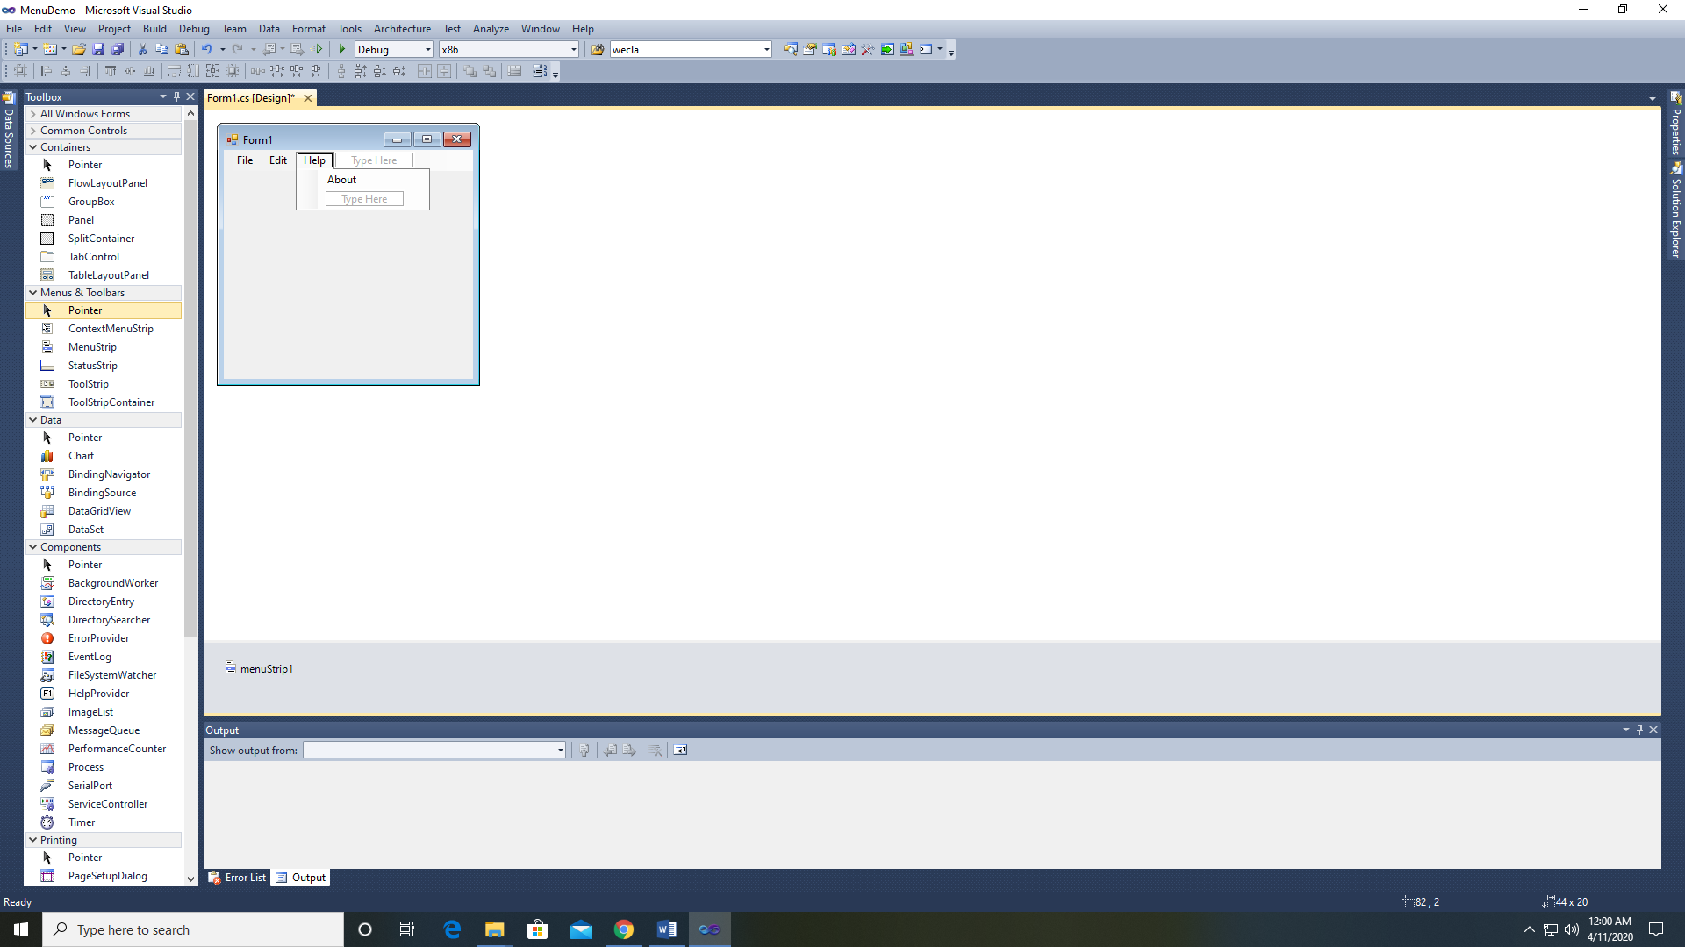

1. Run the program and you should see your menu. Test it out to make sure it is working.

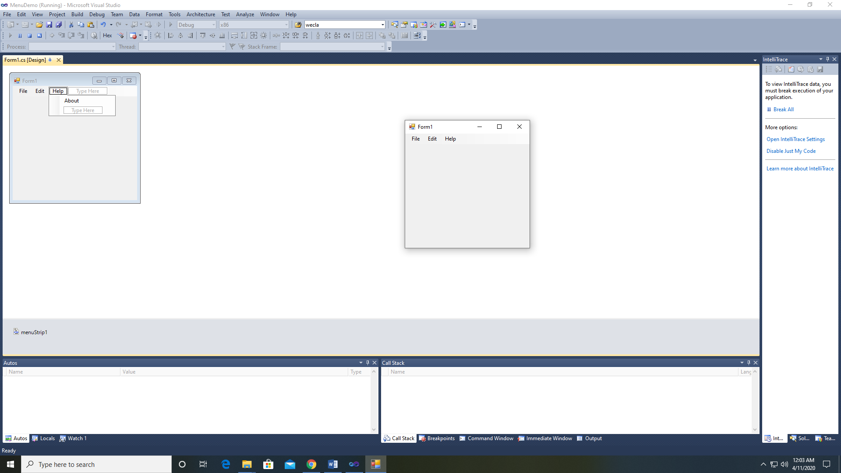

1. Now that your program has a MenuStrip, we need to add event handlers. Notice that the MenuStrip adds a MenuBar. The top level menu can be thought of as categories. The submenu items are elements that will have some event associated with them. To create the event handler for menu items, simply double-click on the menu item.

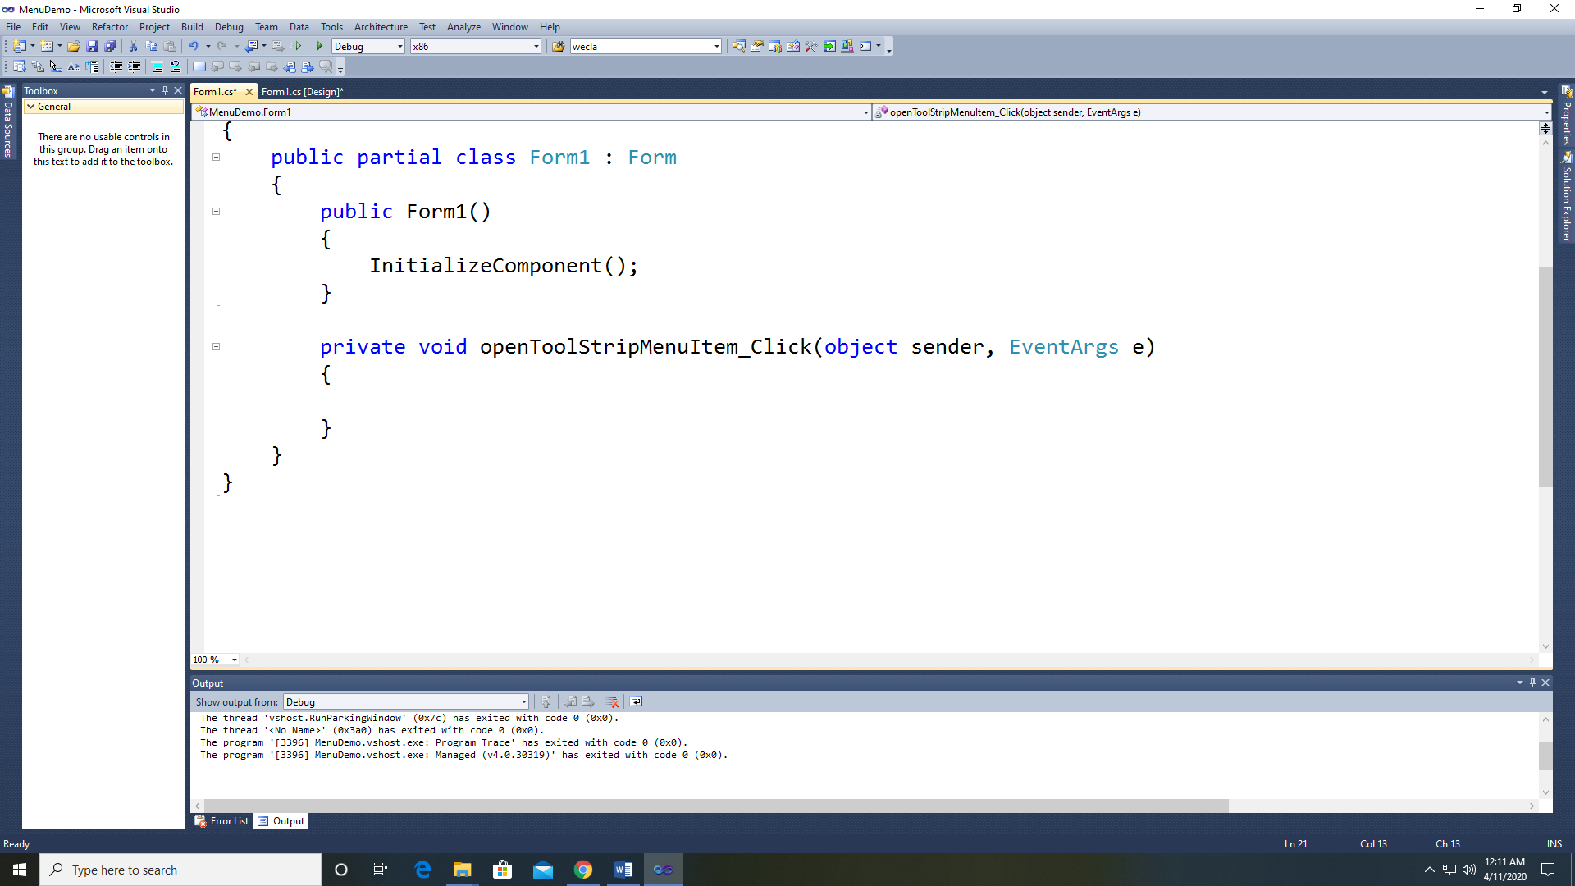

1. Notice how it names it using the text of the Menu Item. Simply type the code in the event handler you wish to execute when that menu item is selected. For this example we will create a MessageBox to show which menu item was selected.
2. Add the code for the Exit menu item.

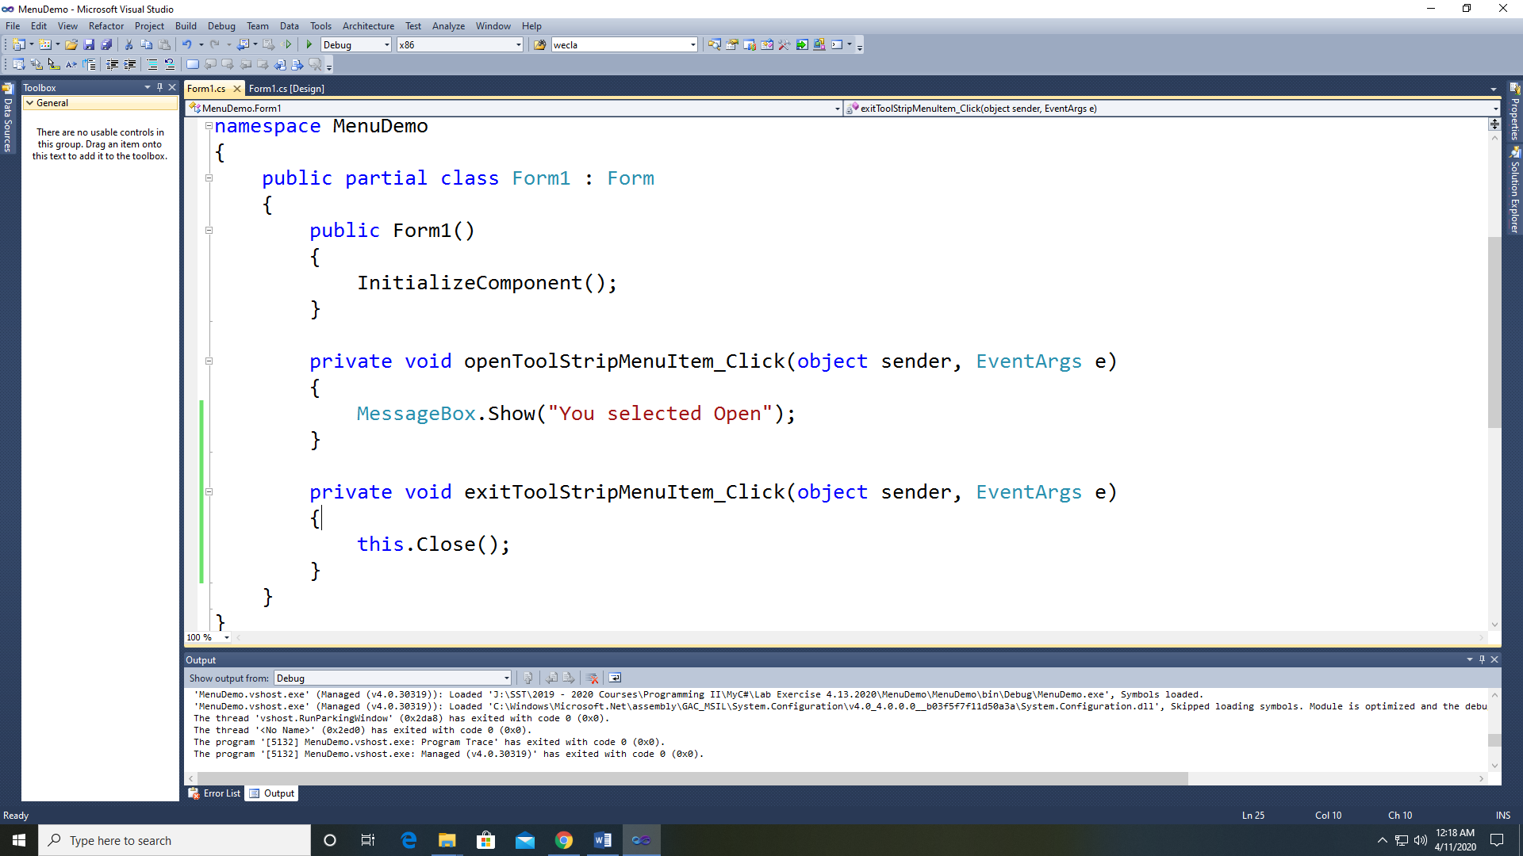

1. Repeat step 5 and 6 for the other menu items. We normally do not assign events to the top level menu items (File, Edit, and Help).
2. Now test your program.